CRUISE REPORT
Cruise Number: DY14-06
FOCI Number: DY14-06
Ship:
NOAA Ship Oscar Dyson
Area of Operations:
Eastern Bering Sea
Itinerary:
Date depart/port: May 20, 2014/Dutch Harbor, AK
Date arrive/port: June 8, 2014/Dutch Harbor, AK
Participating organizations:
AFSC/Eco-FOCI
AFSC/EMA
PMEL

Chief Scientist:
Steven Porter M/AFSC
(206) 526-4271
steve.porter@noaa.gov
Personnel:
Alex Andrews M/EMA
Debbie Blood F/AFSC
Lisa Guy F/PMEL
David Struasz M/PMEL

Cruise Objective:
The primary objective was to conduct an assessment of eggs and larvae of Walleye Pollock (Gadus chalcogrammus) over the eastern Bering Sea shelf. The data collected will be used to examine the interactions among climate, weather, and ichthyoplankton distribution and abundance. This work is needed to describe larval fish assemblages and determine how physical and biological factors affect the transport and survival of fish larvae. The survey is a collaboration between two Alaska Fisheries Science Center (AFSC) programs, Ecosystems and Fisheries Oceanography Coordinated Investigations (Eco-FOCI), and Ecosystem Monitoring and Assessment (EMA).

Summary of Operations:
Operation Tows
60cm bongo (60BON) 243
20cm bongo (20BON) 243
CalCOFI vertical egg tow net (CALVET) 16
Seabird FastCAT CTD (CAT) 259
CTD without bottle samples (CTD) 3

Samples Collected Tows Number
SeaBird FastCAT CTD (CAT) 259
Larval fish for DNA barcode (AMGEN) 240 8329
SeaBird CTD (CTD) 3
Quantitative tow preserved in formalin (QTowF) 240 571
Rough count of pollock larvae 240 26676
Zooplankton for Ron Heintz bioenergetics (RH_ZP) 48 65 (tubes)
Pollock larvae for Steve Porter flow cytometry (SPFCM) 23 253

Summary of Cruise:
Narrative:
The ship departed Dutch Harbor on 20 May 2014 at 1300 local time. Zooplankton and ichthyoplankton were sampled using a paired 20 and 60-cm Bongo array with 153µm and 505µm mesh nets respectively. The first five stations were over Bering Canyon and were not part of the Eco-FOCI sampling grid (Fig. 1). Those stations were done because the project prior to DY14-06 did not have time to complete them. The Bering Canyon stations were completed on 21 May at 0200 and then the ship proceeded to the first station of the Eco-FOCI grid. The grid was started on the southern outer shelf along the Alaska Peninsula at station BD1 (southwestern most station) on 21 May at 0600 (Fig. 1). Sampling of the southern outer and middle shelf continued east along the peninsula and was finished on 27 May at 0530. For the southern area, rough counts of Walleye Pollock larvae showed that they were concentrated to the east on the middle shelf (Fig 2). After the southern area was completed, Bongo sampling continued northward toward the Pribilof Islands (Fig. 1). We stopped operations on 31 May at 0400 to travel to St. Paul Island to evacuate a crew member with a medical condition. The Fast Rescue Boat developed a mechanical problem while taking the crew member to shore and repairs to the boat delayed our departure from St. Paul for about 6 hours. Station operations did not resume again until 0600 on 1 June. The survey of the area around the Pribilof Islands was completed on 3 June at 1100. Based on larval rough count, that area had the highest abundance of Walleye Pollock larvae for the whole survey. High abundance of Walleye Pollock larvae may have continued further east but this was not investigated due to the time constraint of wanting to complete the northern most stations of the grid. In past years the area north of the Pribilof Islands was not accessible due to sea ice, but 2014 is considered a “warm” year in the Bering Sea and sea ice extent was not as far south as it has been during previous “cold” years. The survey of the area north of the Pribilof Islands was completed on 6 June at 1600 (Fig. 1). Walleye Pollock larvae abundance declined in that area, but they continued to be caught up to the northern most stations (Fig. 2). Additional sampling was conducted on the CB and CE lines (two western most north-south lines) on transit back to Dutch Harbor (Fig. 1). Walleye Pollock larvae were not as abundant there as they were in the east (Fig. 2). The final station was completed on 7 June at 1400, and the ship arrived at Dutch Harbor on 8 June at 0900. On 8 and 9 June, gear was offloaded for storage at OSI and placed into a container for shipment back to Seattle.

Special Studies
Samples were collected throughout the survey for special projects: Walleye Pollock larvae for condition (S. Porter NOAA/AFSC), molecular identification of fish larvae (A. Matarese NOAA/AFSC), and Zooplankton for bioenergetics (R. Heintz NOAA/AFSC).

Days Lost to Weather:
0
Days Lost to Equipment Failure:
0
Acknowledgments:
The scientific party would like to acknowledge the hard work and support of the Officers and Crew of the NOAA Ship Oscar Dyson who helped to make our project a success. We would like to thank the Steward Department for delicious meals, Survey and Deck Departments for their assistance deploying our gear, Engineering Department for quickly repairing the FRB so that we could resume operations, and Officers who made sure that operations were conducted in a safe and time efficient manner.

Attachments:
Figure 1. Stations occupied

Figure 2. Rough Count of Walleye Pollock larvae

Table 1. Cruise summary

Fig 1. Stations occupied during DY14-06.
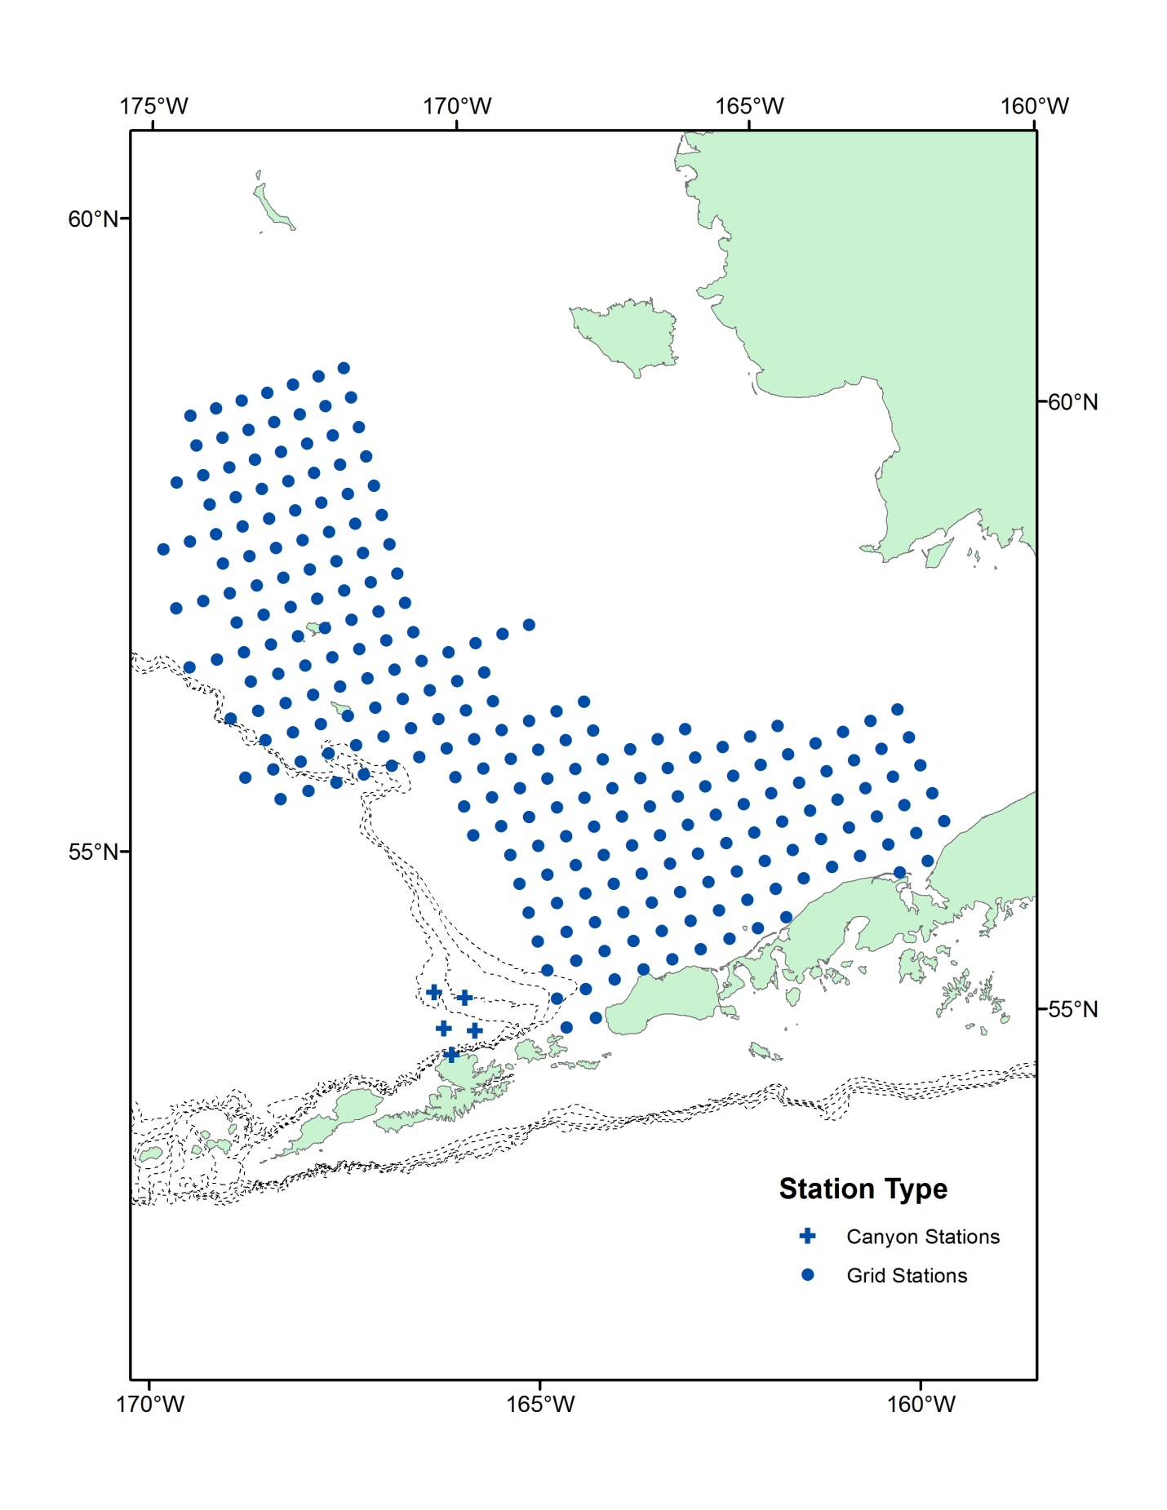

Fig. 2. Rough counts of Walleye Pollock larvae abundance for DY14-06.
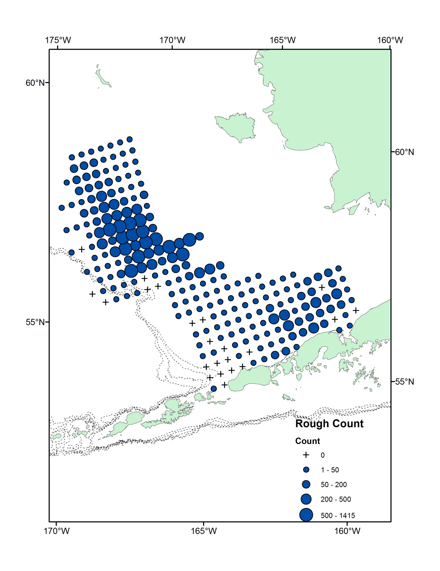
Table 1. DY14-06 cruise summary. Double click on table below for the complete cruise summary (embedded .pdf file).

